|  |  |
| --- | --- |
| **Title** | 11th homework in the Electric Circuit Theory class by 201923250 |

|  |  |  |  |
| --- | --- | --- | --- |
| **Author** | 201923250 | **Date** | 11.9.2020 |

**Practice problem 8.3**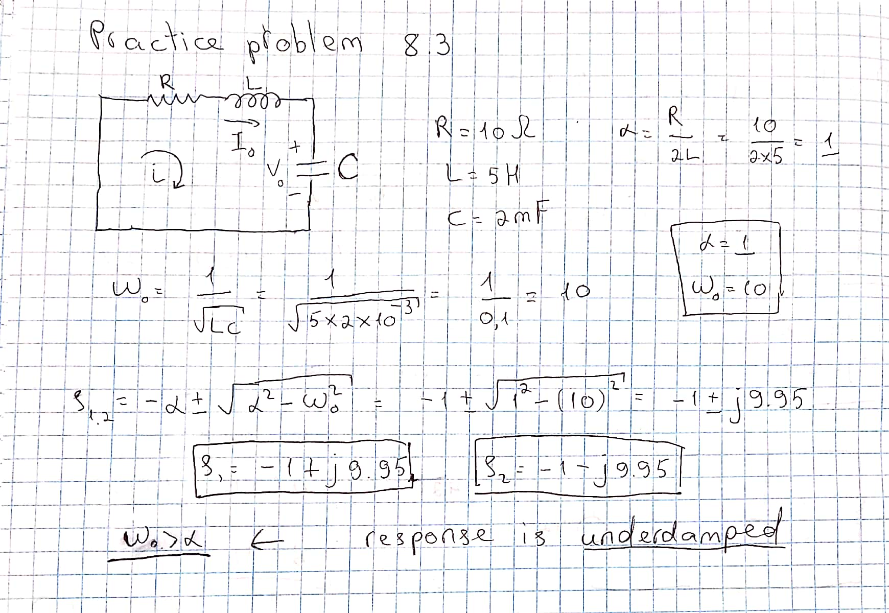

**Practice problem 8.1**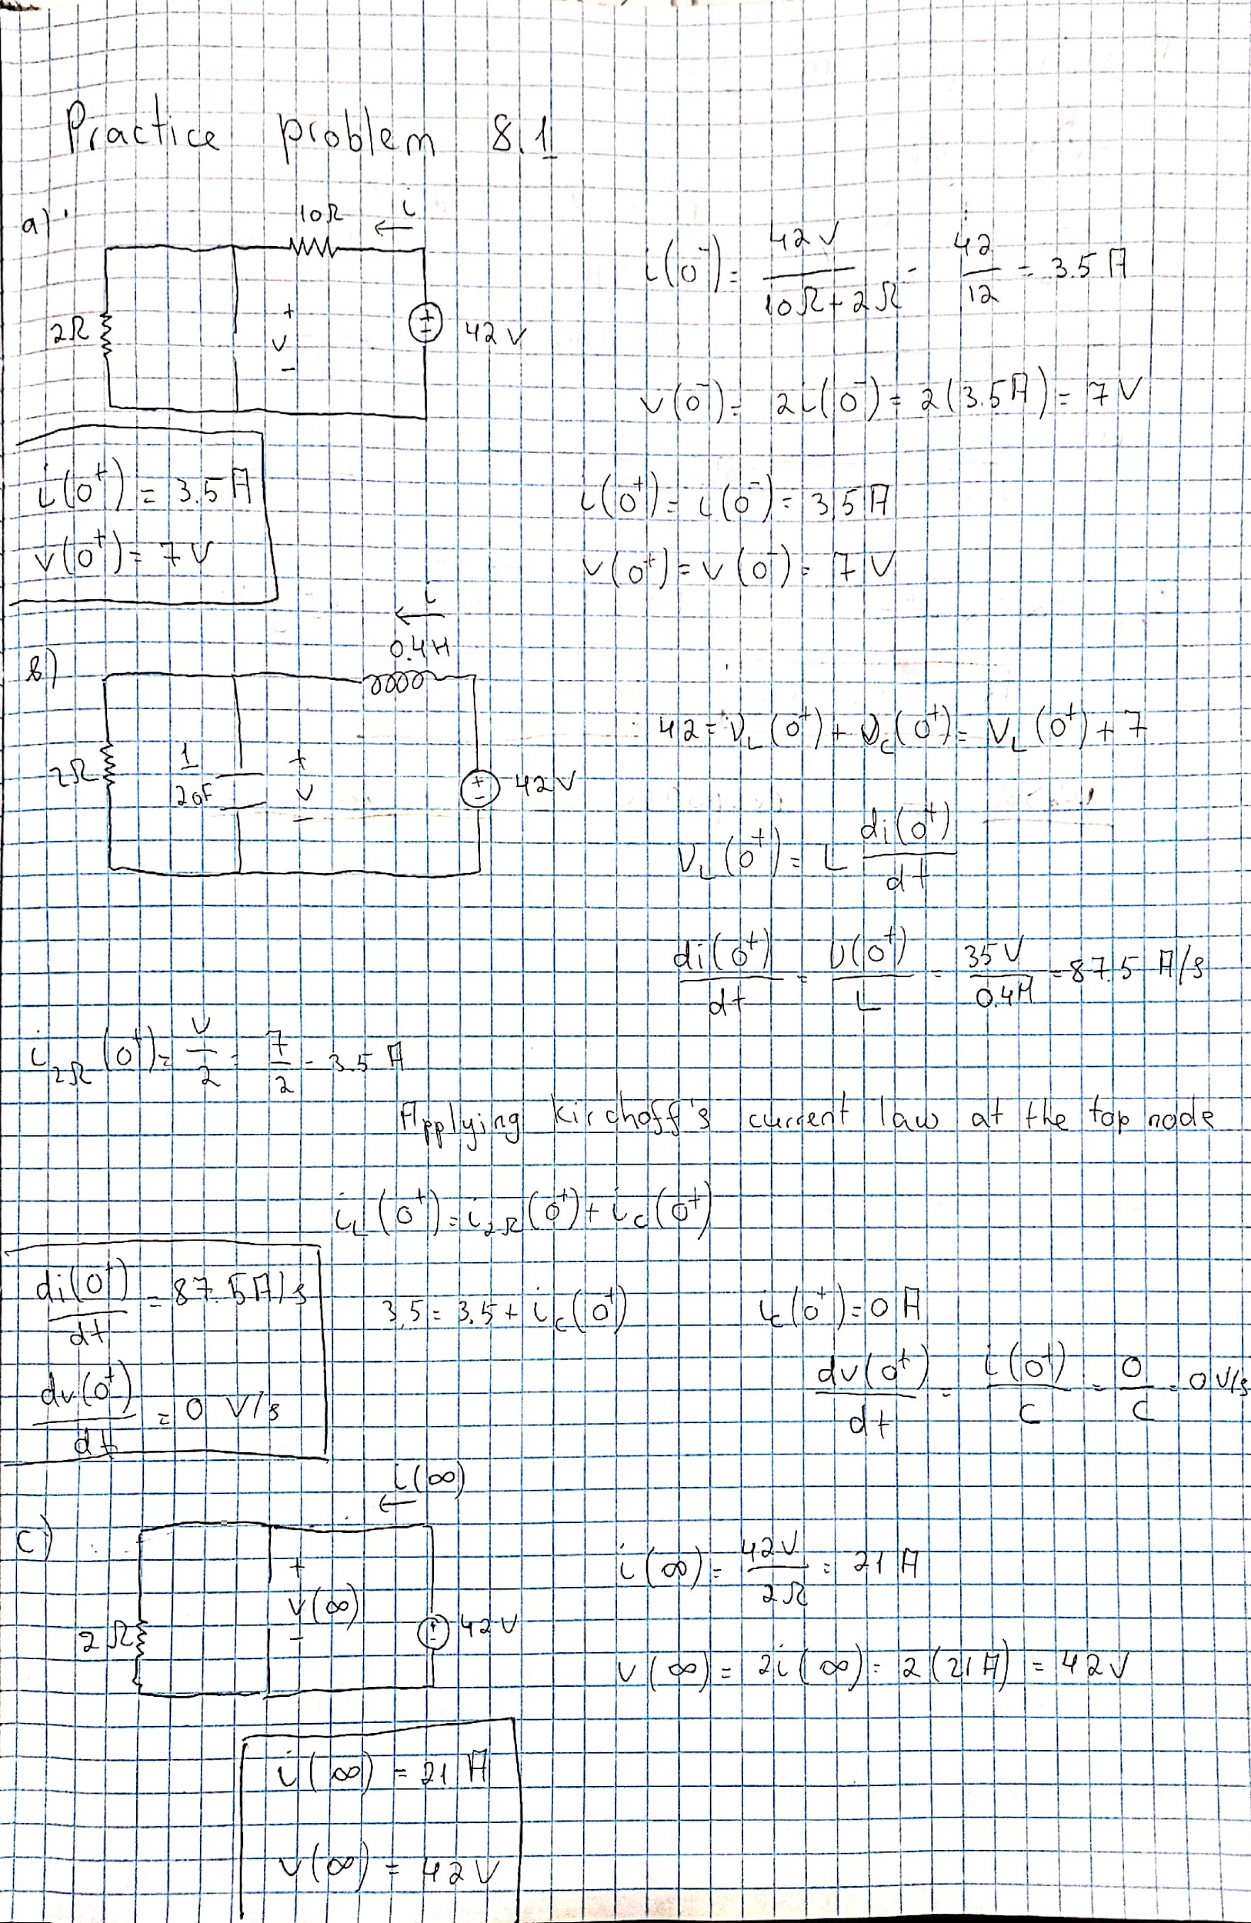

**Practice problem 8.4**